|  |
| --- |
| hARDIK D Shah |
| GAME2014-F2021-Assignment1 |
| **A Classic Arcade Game** |
| Version #04  All work Copyright © 2021 by XX Games.  All rights reserved. |
| **Hardik Dipakbhai Shah** |
|  |



**Insert a Company Logo here**

|  |
| --- |
| October 3, 2021 |

**Table of Contents**

|  |  |  |
| --- | --- | --- |
| 1 | Version History | Page 3 |
| 2 | **Game Overview** | **Page 4** |
| 3 | **Gameplay Mechanics** | **Page 4** |
| 4 | **Camera** | **Page 4** |
| 5 | **Controls** | **Page 4** |
| 6 | **Saving and Loading** | **Page 4** |
| 7 | **Interface Sketch** | **Page 4** |
| 8 | **Menu and Screen Descriptions** | **Page 5** |
| 9 | **Game World** | **Page 8** |
| 10 | **Levels** | **Page 8** |
| 11 | **Game progression** | **Page 8** |
| 12 | **Characters** | **Page 9** |
| 13 | **Non- player Characters** | **Page 9** |
| 14 | **Enemies** | **Page 9** |
| 15 | **Weapons** | **Page 9** |
| 16 | **Items** | **Page 9** |
| 17 | **Abilities** | **Page 9** |
| 18 | **Vehicles** | **Page 9** |
| 19 | **Script** | **Page 9** |
| 20 | **Scoring** | **Page 10** |
| 21 | **Puzzles/Minigames** | **Page 10** |
| 22 | **Bonuses** | **Page 10** |
| 23 | **Cheat Codes** | **Page 10** |
| 24 | **Sound Index** | **Page 10** |
| 25 | **Story Index** | **Page 10** |
| 26 | **Art/ Multimedia Index** | **Page 10** |
| 27 | **Design Notes** | **Page 10** |
| 28 | **Future Features** | **Page 10** |

**Version History**

**Version#01 (09/30/2021) –** Initial concepts of the game’s design were written. These concepts are based on the ideas Many sections are empty or incomplete, these will be added to/removed as pre-production progresses.   
  
**Version#02 (10/01/2021) –** Added details to “Gameplay Mechanics” section and added level details to the “Levels” section. Also added more specific controls for players and enemies.  
  
**Version#03(10/02/2021) –** First official interaction. Dynamics, mechanics, and aesthetics are clearly defined along with many of the basic game features. Some concept arts for stages and screens are included as well as screenshots for what the main gameplay screen and main menu looks like. **Version#04(10/03/2021) –** Updated all the section information as well as describe all the figures attached into the documents.

1. **Game Overview**

*In each level the player survives against numerous enemies and bullets for a certain period. The game will be made with an E10+ rating in mind, utilizing no foul language but having cartoon violence. The game plays top to bottom where player will be at the bottom position and enemies will be at the top firing projectiles with each other. The game will be aimed at a android release.*

1. **Game Play Mechanics**

*The player controls the protagonist using standard AD or arrow keys to move left and right and Spacebar to shoot the projectile. This will move the player’s sprite in whichever direction is pressed.*

1. **Camera**

*It is orthographic camera which will cover entire gameplay. With z-axis towards -10 and y-axis towards -1, x-axis towards 0.*

1. **Controls**

*The player can move around left and right with A and D keys respectively. Player can shoot projectile with the spacebar and right mouse click.*

1. **Saving and Loading**

*Unlikely to be determined.*

1. **Interface Sketch**

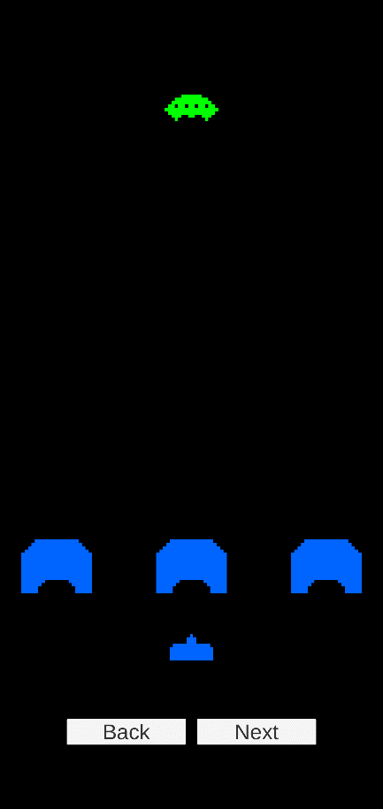

**Figure 1 – Main game Level Sketch (more enemies to be added in future Levels)**The Main game looks like this where the player shoots projectile from the bottom of the screen towards the top, whereas the enemy will shoot from the top to bottom. There will be 3 Bunkers where player can hide to save the life. The bunkers will take damage on every projectile hit.

1. **Menu and Screen Descriptions**

***Figure 2 – Main Menu screen with buttons****The Main Menu looks like this. It have Play and Instruction buttons. If player clicks the Play button it will be go towards the Game Level(Ref. Figure 1) and if player clicks on Instructions button then it will go towards the Instruction Tab (Ref. Figure 3)*

***Figure 3 – Instructions Screen****This is what Instruction screen looks like, the player can move back to the Main Menu from this tab.* ***Figure 4 – GameOver Screen***

There will be 2 conditions in here. If player dies or player wins this screen will pop up. From there player has two options to restart the game again or go to main menu.

1. **Game World**

*(Describe Your Game Environment)*

1. **Levels**

*As of now it just has one Level where the player and enemies are positioned into the scene. There are 3 Bunkers placed into the scene as well (Ref. Figure 1)*

1. **Game Progression**

To progress through the game the player must survive long enough to reach the end of the level as well as kill the enemies with the ability to shoot.

1. **Characters**

*It looks like a ship which is at the bottom of the screen.*

1. **Non-player Characters**

**Bunker -** To protect the player from the enemy’s projectile. Player can hide from those to not take the damage.

1. **Enemies**

***Mystery Ship -*** *This enemy will shoot projectile to kill the player. There will be other enemies as well into next iteration.*

1. **Weapons**

*Player and enemies both has a projectile component so they can shoot at each other to kill.*

1. **Items**

*Bunkers which will help the player to hide from the enemies projectile.*

1. **Abilities**

Player can shoot and move around on the screen with A and D keys and shoot with the spacebar and right mouse click.

1. **Vehicles**

N/A

1. **Script**

The script added for changing the Scene. Into the next interactions will update the Player movement and shooting behavior script, enemies’ movement and shooting behavior scripts.

1. **Scoring**Player can score with each perfect shot and kill the enemies.
2. **Puzzles/Mini-games**

N/A

1. **Bonuses**

N/A

1. **Cheat Codes**

Unluckily to be added.

1. **Sound Index**

*$.... \GAME2014-F2021-Assignment1\Assets\Sounds*

1. **Story Index**

*(Outline your game story here)*

1. **Art / Multimedia Index**

*$... \GAME2014-F2021-Assignment1\Assets\Sprites*

1. **Design Notes**

*N/A*

1. **Future Features**

*More Level with different mechanics of the enemies and player.*